**FINAL DELIVERABLES**

|  |  |
| --- | --- |
| Team ID | PNT2022TMID47521 |
| Project Name | Project – IOT based smart crop protection system for agriculture |
| Team Leader | B.Rajeshwari |
| Team Members | S.Muthunandhini, M.Mowniga devi, K.Maheswari |

**ABSTRACT:**

Food is the most important requirement for living beings. The main products of our food come directly or indirectly from agriculture. Now a days security of especially at high frequencies, and the gradual loss of sensitivity to higher agricultural field is very important. Crop damage by birds is a severe problem in most of the areas all over India. Field surveys showed that on an average 36% of the crop were damaged by wild birds. The incident of damage was very high in crop fields adjacent to forest areas, this resulted into direct conflict between people and birds. In everyday life farmers facing different kind of problems in agriculture. In olden days different kind of animals enter into crop they are damaging the fields. For reducing those kinds of problem they are used different kind of technique. Now a day birds are major problem in agriculture. Birds are falling on crop and eating it. In this research paper we are solving some problems. Every animal or group of animal is having a specific range of hearing frequencies. There irritating frequency is estimated by a specific logic. In day life birds creating irritating sounds in agriculture and out sides’ fields also. At early morning and evening time birds falling on the crops and eating rice seeds, rabi crops, cons and wheat….etc. so we can create irritating sounds for birds, and then they can flay outside of the field. By using this research idea we can able to reduce mostly affected problem in agriculture.

**INTRODUCTION:**

This will be an integrative approach in the field of IIOT designed for perceptive Agriculture which are proceeding the arrangements in course of open source and on low powers devices . This project work is to yield monitoring arrangement for farm safety against animal attacks and climate change conditions. Industrial Internet of Things (IIoT) advances is frequently used in smart farming to emphasize the standard of agriculture. This project work contains various sorts of sensors, controllers in addition to positioner on behalf of WSN and ARM Cortex-A board which consumes 700mA or 3W power is the main temperament of the classification. Different sensors like DHT 11 Humidity & Temperature Sensor, PIR Sensor, LDR sensor, HC-SR04 Ultrasonic Sensor and cameras are interfaced with the board. IOT devices stay adept of in case evidence around farming grounds. As soon as the passive infrared sensors (PIR) go High on detecting the motion within a range of 10 meters, the camera will be turned ON which first captures an image and then starts dealing out the image, which will be warehoused onboard as well as in IoT cloud, instantaneously a message will be generated automatically towards the recorded quantity using a SIM900A module to inform about the intrusion with the data of the temperature as well as humidity obtained by dht11 which is a temperature and humidity sensor. If found not to be human after processing the available information the system elevates a buzzer sound, to notify people about the intrusion. Data collected by the sensors will be given to ARM CortexA through the systems which can be wired or communicataion system. The facts in the porter is tested and harmonized with superlative values of data like value of temperature, humidity and soil moisture. If the difference occurred concerning predefined threshold rate formerly announcement sends to the mobile of the farmer or to the website. The result will be generated arranged the database of the farmer's mobile to take the necessary action . The Internet of Things (IOT) is an evolving paradigm that seeks to connect different smart physical components for multi-domain modernization. To automatically manage and track agricultural lands with minimal human intervention, numerous IOT-based frameworks have been introduced. This paper presents a rigorous discussion on the major components, new technologies, security issues, challenges and future trends involved in the agriculture domain. An in-depth report on recent advancements has been covered in this paper. The goal of this survey is to help potential researchers detect relevant IOT problems and, based on the application requirements, adopt suitable technologies. Furthermore, the significance of IOT and Data Analytics for smart agriculture has been highlighted.

**LITERATURE SURVEY:**

Between 1974 and 1991, the amount of damage caused by sparrows in Japan showed a sharp drop. Since the main crop eaten by sparrows is rice, this probably reflects the decline in the area of paddy fields over that period. Damage by other birds increased, however, especially by the brown-eared bulbul. On the whole, crop damage by birds in Japan is tending to increase.

What are the reasons for this? First of all, the number of birds is increasing. Many farmers are using combines to harvest rice and wheat. Quite a large number of grains reaped in this way are left behind in the field. This gives birds an abundant and high-quality food supply that contributes to the increase in numbers, and keeps it stable.

Furthermore, many farmers are beginning to plant rice by direct seeding rather than by transplanting. The sown seed is a food resource for ducks if the paddy fields are flooded and for sparrows and pigeons if the fields are drained.

In some cases, damage has occurred to new crops. One example is the brown-eared bulbul, which began to eat the leaves of various kinds of leaf vegetables. Bulbuls were formerly migratory birds, which overwintered in the southern part of Japan and bred in the mountainous and northern regions of Japan. In the 1970s, they became year-long residents and began to cause severe damage to winter cabbage and

other leaf vegetables. In the case of Japanese pear, bird damage became much worse after the introduction of new varieties such as Kosui, which have higher sugar content than traditional varieties.

Sometimes a new pest bird species appears. An example is the Chinese bulbul (Pycnonotus saneness) which appeared in Okinawa for the first time in 1976 and began eating the leaves and fruit of vegetables.

**EMPATHY MAP CANVAS:**

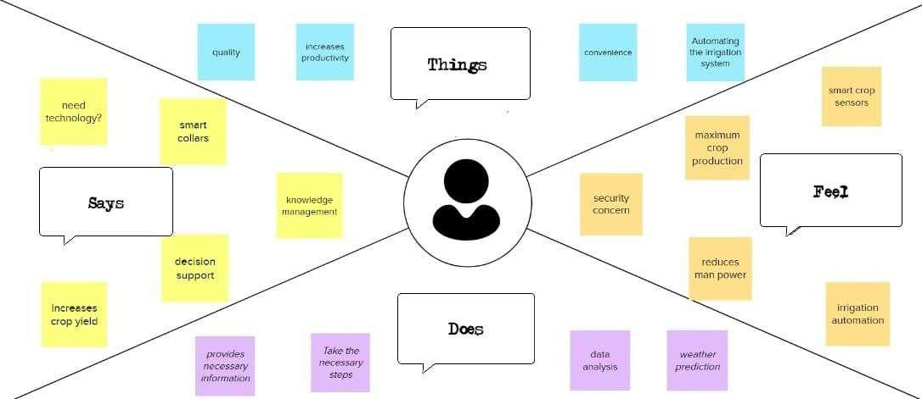

**BRAIN STORMING:**

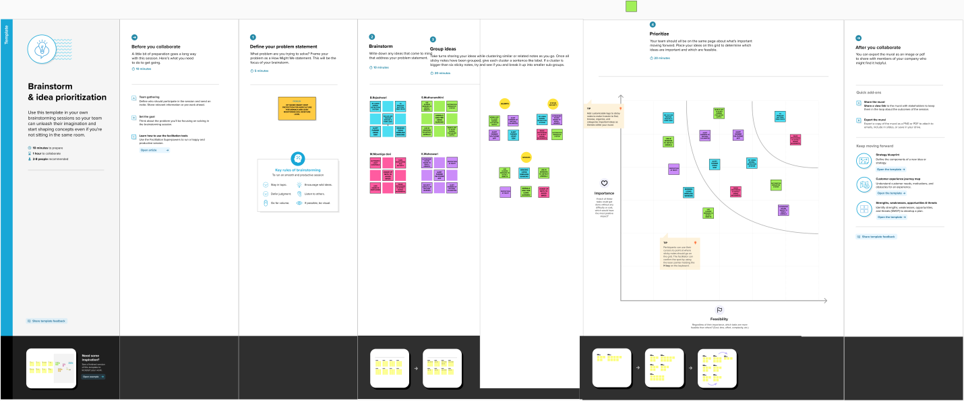

**PROBLEM STATEMENT:**

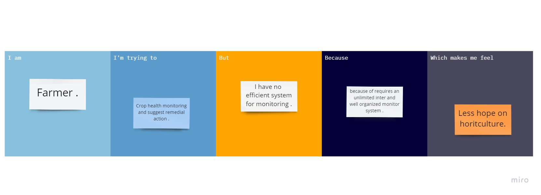

|  |  |  |  |  |  |
| --- | --- | --- | --- | --- | --- |
| **Problem Statement (PS)** | **I am (Customer)** | **I am trying to** | **But** | **Because** | **Which makes me feel** |
| PS-1 | Farmer | To increase productivity | No clarity regarding it | Animals and birds destroy the crops | Worried |
| PS-2 | Farmer | Monitoring the condition of crops | It has some major issues like understanding the technology and updated equipment | It Requires more knowledge regarding latest technology, skills to grasp easily and interest | Annoying and stress full |

**PROBLEM SOLUTION FIT:**

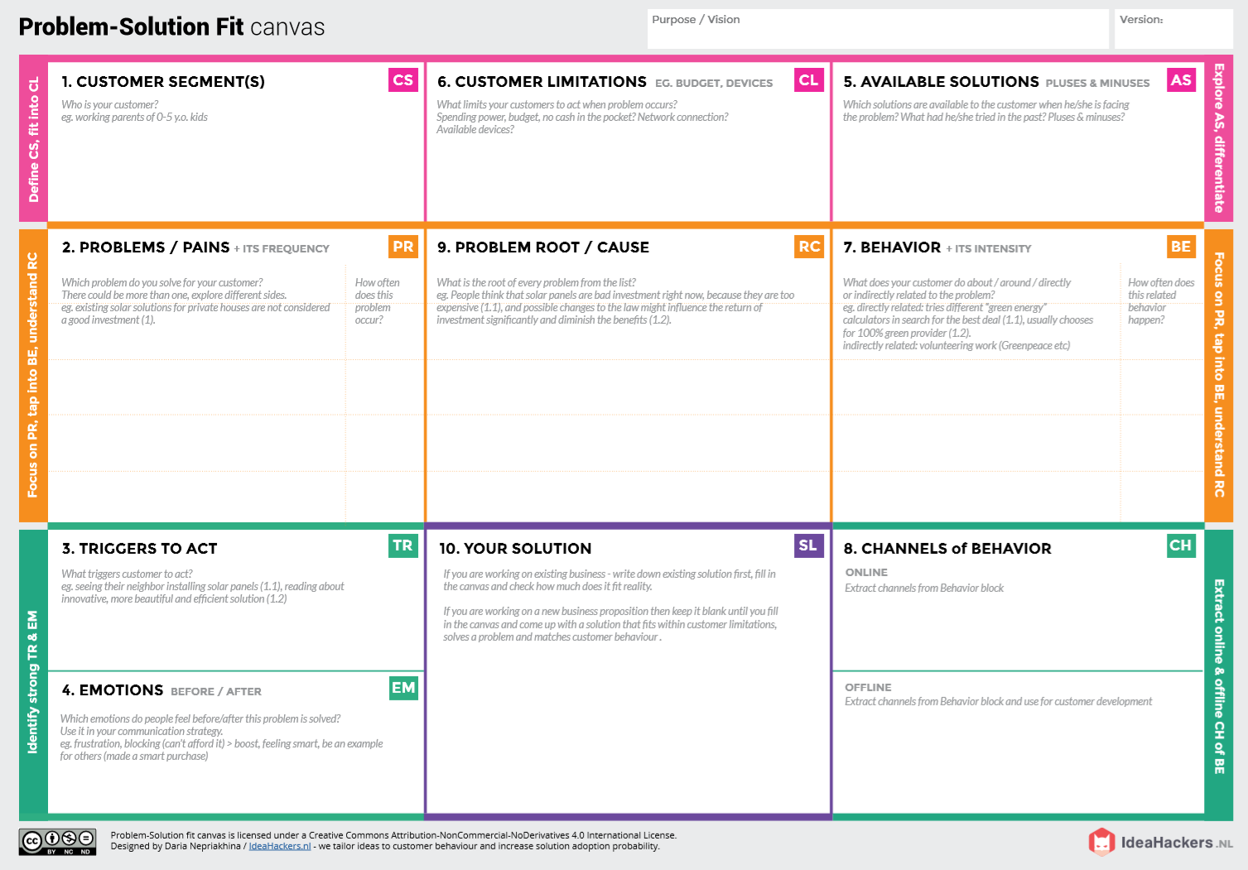

**PROPOSED SOLUTION:**

|  |  |  |  |  |
| --- | --- | --- | --- | --- |
| **S.No.** | **Parameter** | | **Description** | |
| 1. | Problem Statement (Problem to be solved) | | Develop an efficient system & an application that can monitor and alert the users(farmers) | |
| 2. | Idea/Solution description | | * This product helps the field in monitoring the animals other disturbance * In several areas, the temperature sensors will be integrated to monitor the temperature & humidity * If in any area feel dry or wetless is detected by admins, will be notified along with the location in the web application | |
| 3. | Novelty/Uniqueness | | * Fastest alerts to the farmers * The increasing demand for quality food * User friendly | |
| 4. | Social Impact/Customer Satisfaction | | * Easy installation and provide efficient results * Can work with irrespective of fear | |
| 5. | Business Model(Revenue Model) | | * As the product usage can be understood by everyone, it is easy for them to use it properly for their safest organization * The product is advertised all over the platforms. Since it is economical, even helps small scale farming land from disasters. | |
| 6. | | Scalability of the Solution | | * Even when the interruption is more, the product sense the accurate location and alerts the farmers effectively |

**SOLUTION ARCHITECTURE:**

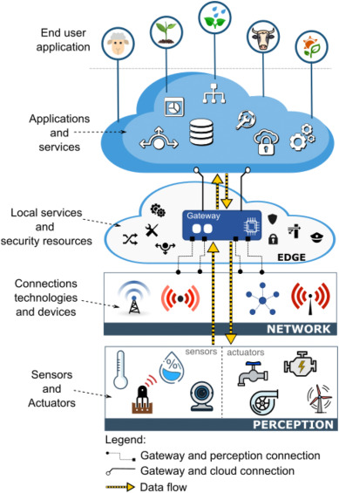

**CUSTOMER JOURNEY:**

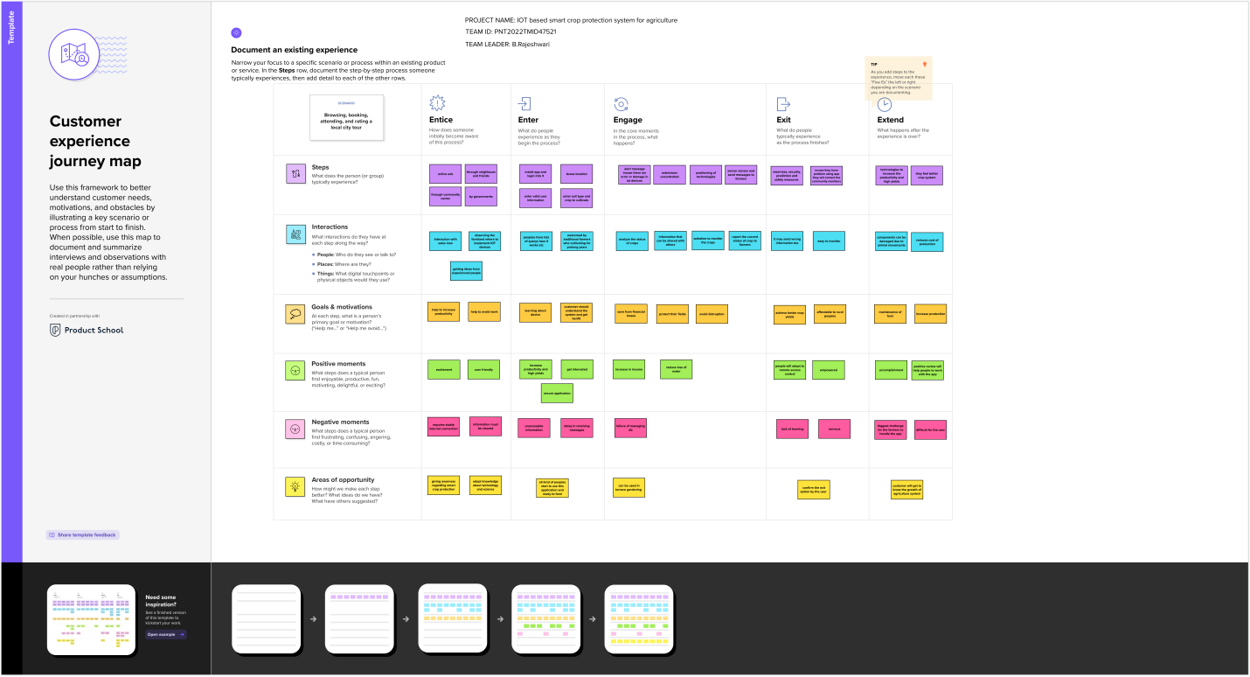

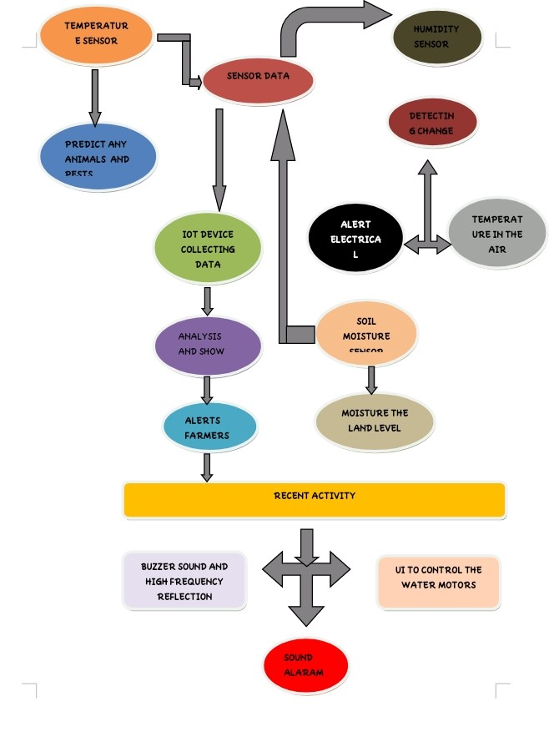**DATA FLOW DIAGRAM& USER STORIES:**

| **User Type** | **Functional requirement (Epic)** | **User**  **Story**  **number** | **User Story/Task** | **Acceptance criteria** | **Priority** | **Release** |
| --- | --- | --- | --- | --- | --- | --- |
| **Customer(Mobile**  **user)** | **Registration** | **USN-1** | **User can enter into the web application** | **I can access my account /dashboard** | **High** | **Sprint 1** |
|  |  | **USN-2** | **User can register their credentials like email id and password** | **I can receive confirmationemail & click confirm** | **High** | **Sprint 1** |
|  | **Login** | **USN-3** | **User can log into the application by entering email & password** | **I can login to my account** | **High** | **Sprint 1** |
|  | **Dashboard** | **USN-4** | **User can view the temperature** | **I can view the data given by the device** | **High** | **Sprint 2** |
|  |  | **USN-5** | **User can view the level of sensor monitoring value** | **I can view the data given by the device** | **High** | **Sprint 2** |
| **Customer(Web user)** | **Usage** | **USN-1** | **User can view the web page and get the information** | **I can view the data given by the device** | **High** | **Sprint 3** |
| **Customer** | **Working** | **USN-1** | **User act according to the alert given by the device** | **I can get the data work according to it** | **High** | **Sprint 3** |
|  |  | **USN-2** | **User turns ON the water motors/Buzzer/Sound Alarm when occur the disturbance on field.** | **I can get the data work according to it** |  | **Sprint 4** |
| **Customer care Executive** | **Action** | **USN-1** | **User solve the problem when some faces any usage issues** | **I can solve the issues when some one fails to understanding the procedure** | **High** | **Sprint 4** |
| **Administration** | **Administration** | **USN-1** | **User store every information** | **I can store the gained information** | **High** | **Sprint 4** |

**SOLUTION REQUIREMENTS:**

**Functional Requirements:**

Following are the functional requirements of the proposed solution.

|  |  |  |
| --- | --- | --- |
| **FR No.** | **Functional Requirement (Epic)** | **Sub Requirement (Story / Sub-Task)** |
| FR-1 | User Registration | Install the app.  Signing up with Gmail or phone number  Creating a profile.  Understand the guidelines. |
| FR-2 | User Confirmation | Email or phone number verification required via OTP. |
| FR-3 | Accessing datasets | Data’s are obtained by cloudant DB. |
| FR-4 | Interface sensor | Connect the sensor and the application  When animals enter the field , the alarm is generated. |
| FR-5 | Mobile application | It is used to control motors and field sprinklers. |

**Non-functional Requirements:**

Following are the non-functional requirements of the proposed solution.

|  |  |  |
| --- | --- | --- |
| **FR No.** | **Non-Functional Requirement** | **Description** |
| NFR-1 | **Usability** | This project’s contributes the farm protection through the smart protection system. |
| NFR-2 | **Security** | Data requires secure access to must register and communicate securely on devices and authorized users of the system who exchange information must be able to do. |
| NFR-3 | **Reliability** | Farmers are able to safeguard their lands by help of this technology. They will also benefits from higher crop yields, which will improve our economic situation. |
| NFR-4 | **Performance** | Must provide acceptable response times to users regardless of the volume of data that is stored and the analytics that occurs in background. Bidirectional, near real-time communications must be supported. This requirement is related to the requirement to support industrial and device protocols at the edge. |
| NFR-5 | **Availability** | We can defend the crops against wild animals by creating and implementing resilient hardware and software. |
| NFR-6 | **Scalability** | System must handle expanding load and data retention needs that are based on the upscaling of the solution scope, such as extra manufacturing facilities and extra buildings. |

**TECHNOLOGY STACK:**

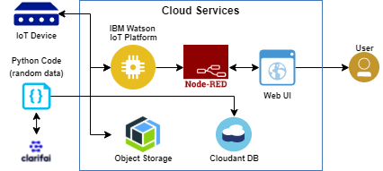

**Table-1 : Components & Technologies:**

|  |  |  |  |
| --- | --- | --- | --- |
| **S.No** | **Component** | **Description** | **Technology** |
|  | User Interface | How user interacts with application e.g.  Web UI, Mobile App, Chat bot etc. | HTML, CSS, JavaScript / Angular Js / React Js etc. |
|  | Application Logic-1 | Logic for a process in the application | Python |
|  | Application Logic-2 | Logic for a process in the application | IBM Watson/node red |
|  | Application Logic-3 | Logic for a process in the application | IBM Watson/node red |
|  | Database | Data Type, Configurations etc. | My SQL, No SQL, etc. |
|  | Cloud Database | Database Service on Cloud | IBM Cloudant. |
|  | Temperature sensor | Monitor the temperature | TMP36 |
|  | Humidity sensor | Monitor the humidity | DHT11 |
|  | Soil moisture sensor | Measure the amount of water in the soil | Soil moisture sensor |
|  | Weather monitoring | Monitor the weather | Temperature sensor |

**Table-2: Application Characteristics:**

| **S.No** | **Characteristics** | **Description** | **Technology** |
| --- | --- | --- | --- |
|  | Open-Source Frameworks | Clarifai, Node- red | Software |
|  | Security Implementations | Sensitive and private data must be protected from their protection untill the decision-making and storage stages. | Encryption process |
|  | Scalable Architecture | Scalability is a major concern for IOT platform it has been shown that different architectural choices of IOT platform affect system capability and that automatic real time decision making is feasible in an environment composed of dozens of thousand. | Software |
|  | Availability | Automatic adjustment of farming equipment made possible by linking information like crops/weather and temperature, humidity etc. | Software |
|  | Performance | The ideas of implementing integerated sensors with sensing soil and environmental or ambient parameters in framing will be more efficient for overall monitoring . | Software |

**CREATE IBM WATSON IOT PLATFORM:**

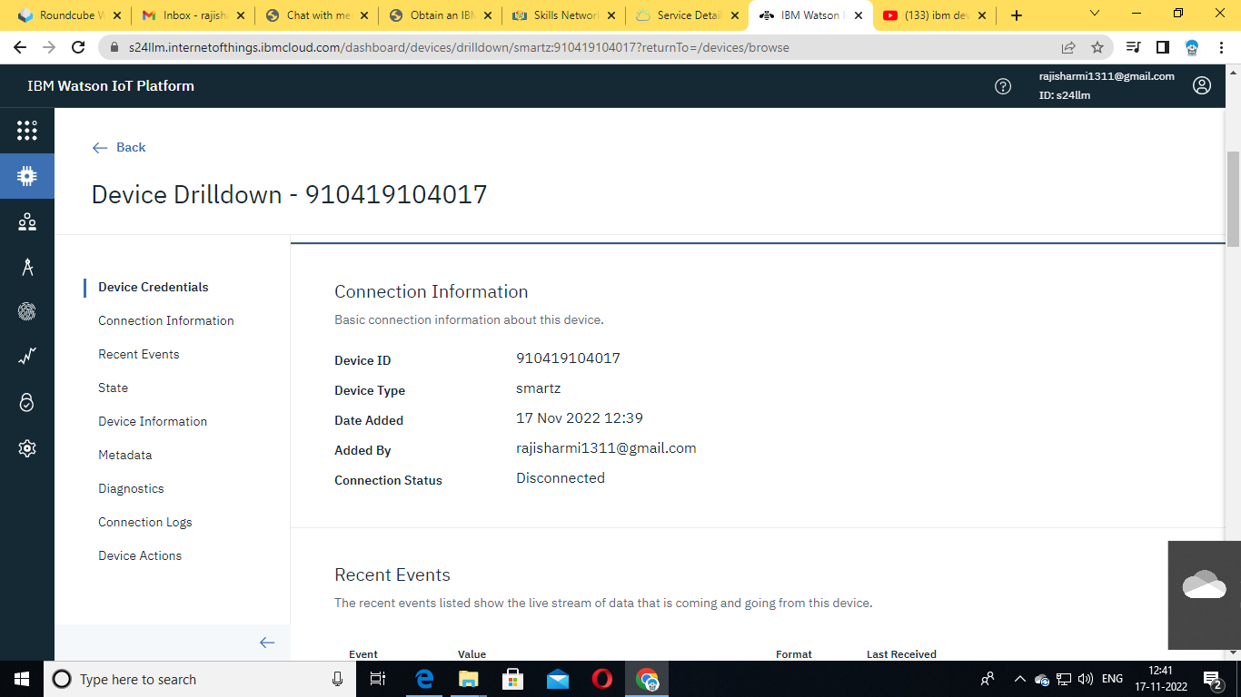

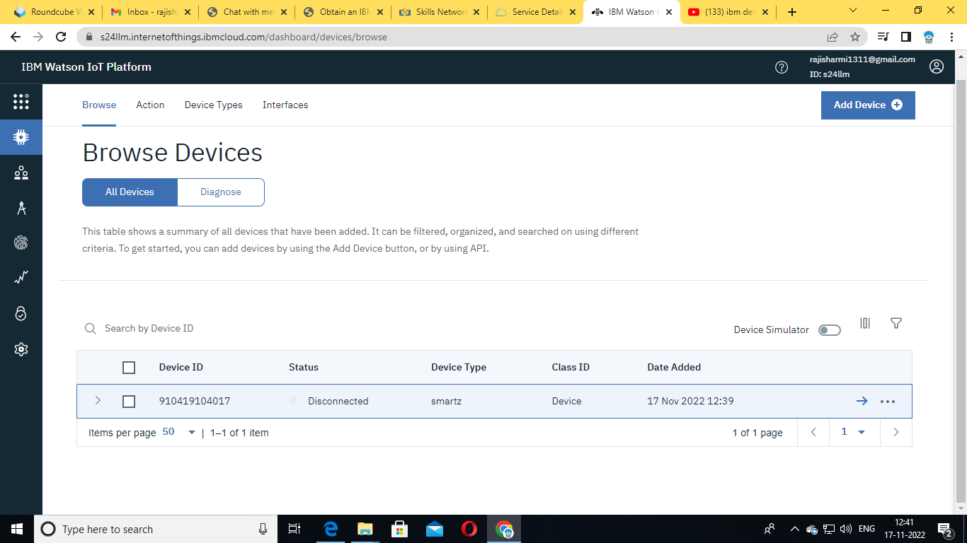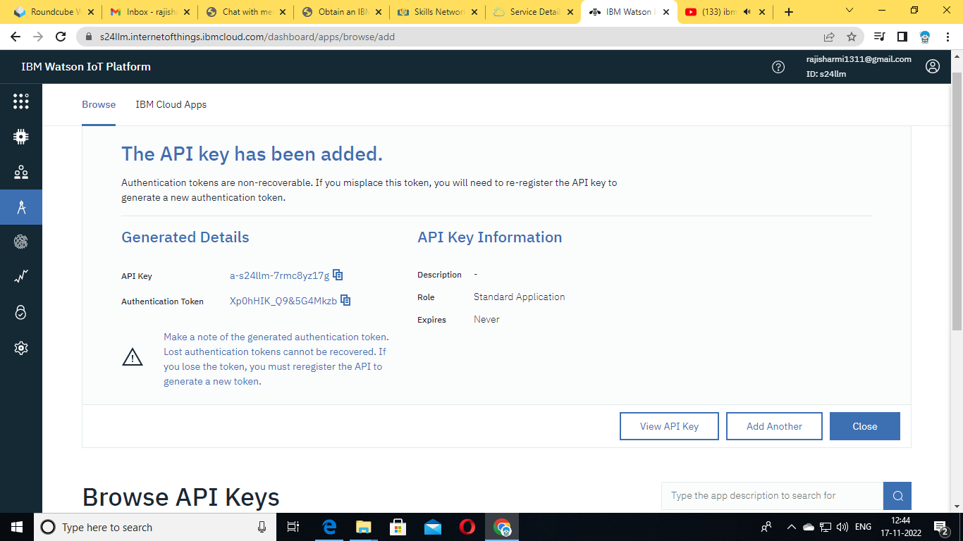

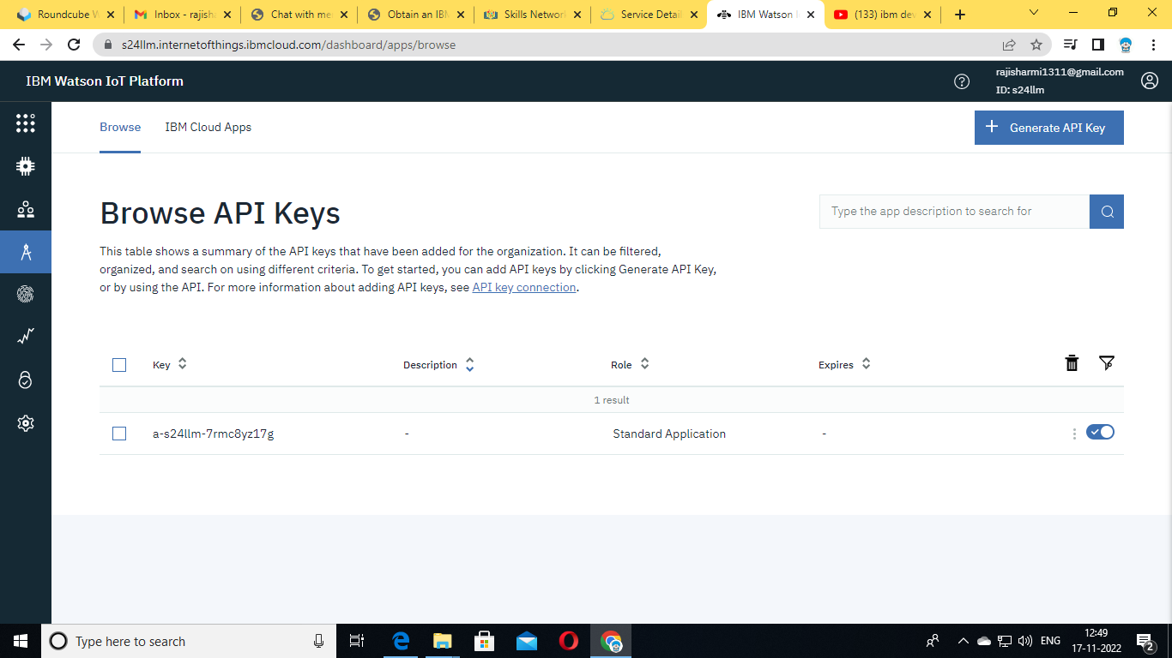

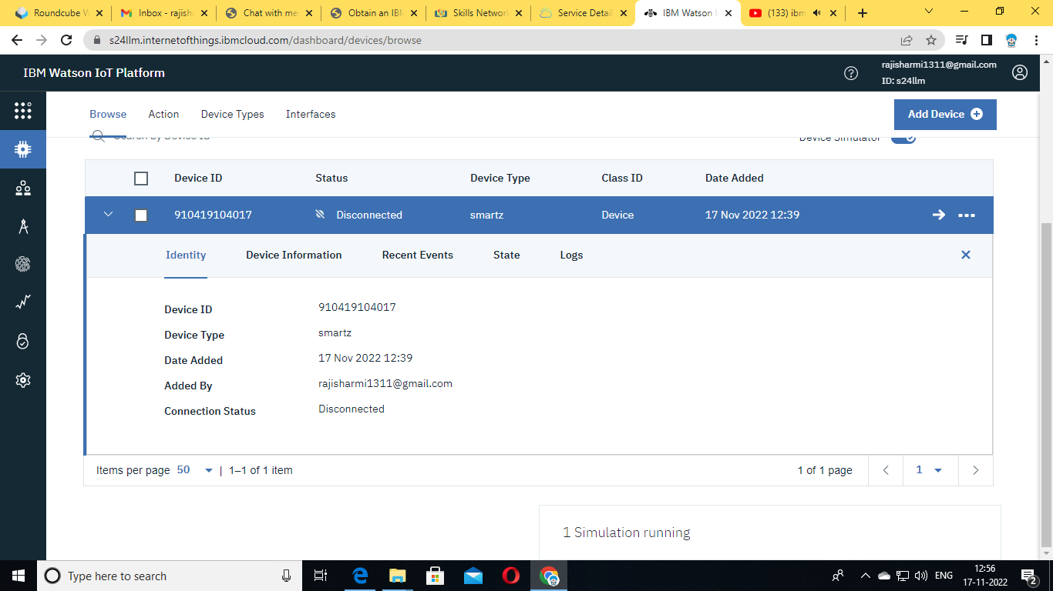

**CREATE NODE RED SERVICES:**

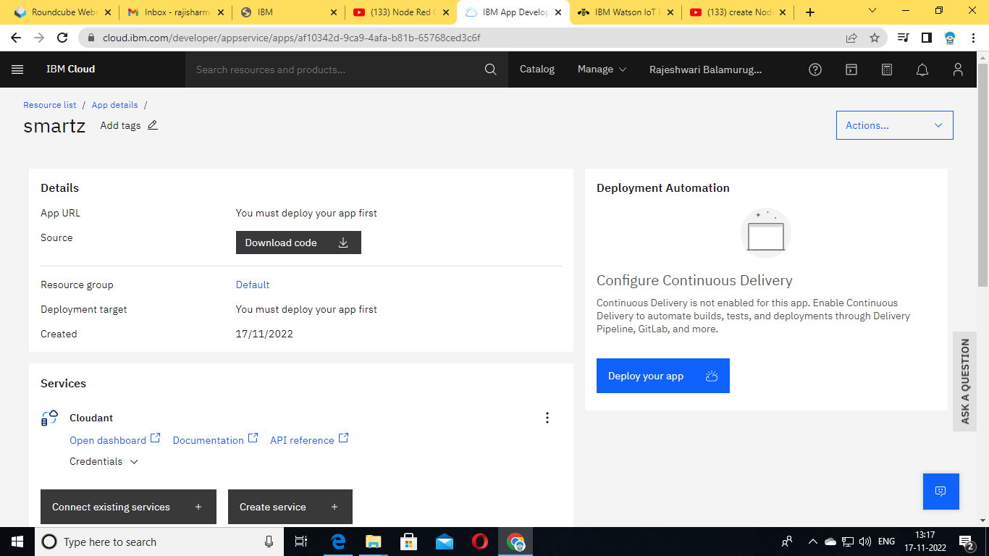

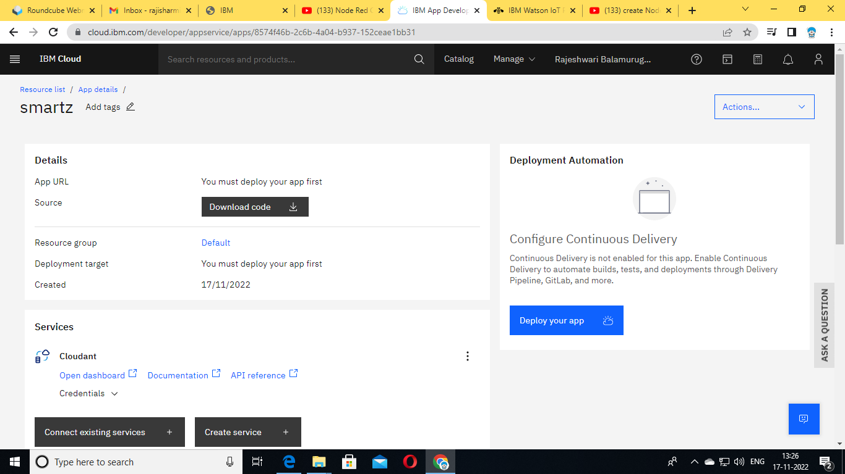

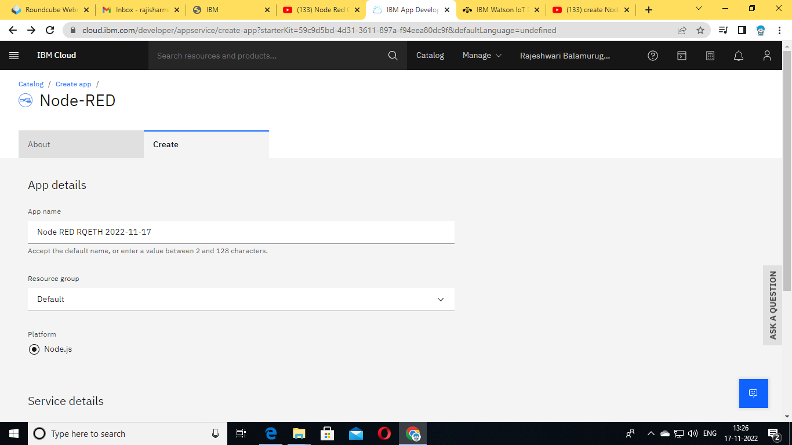

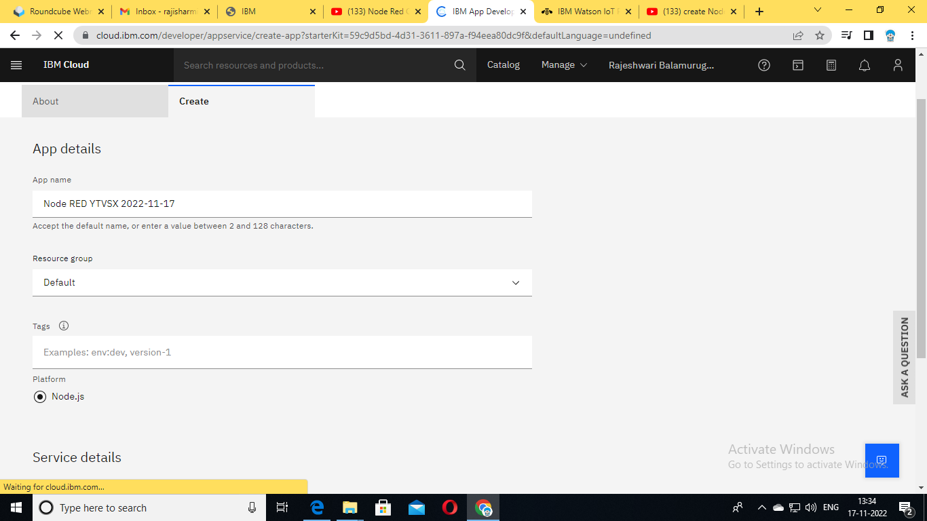

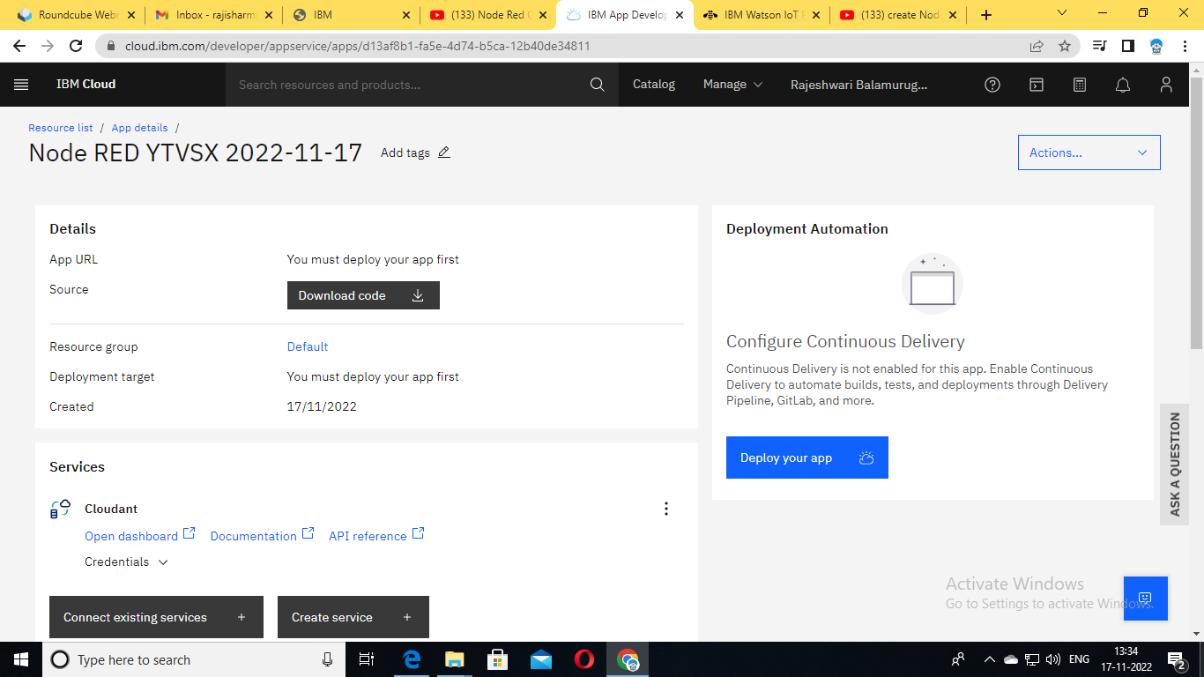

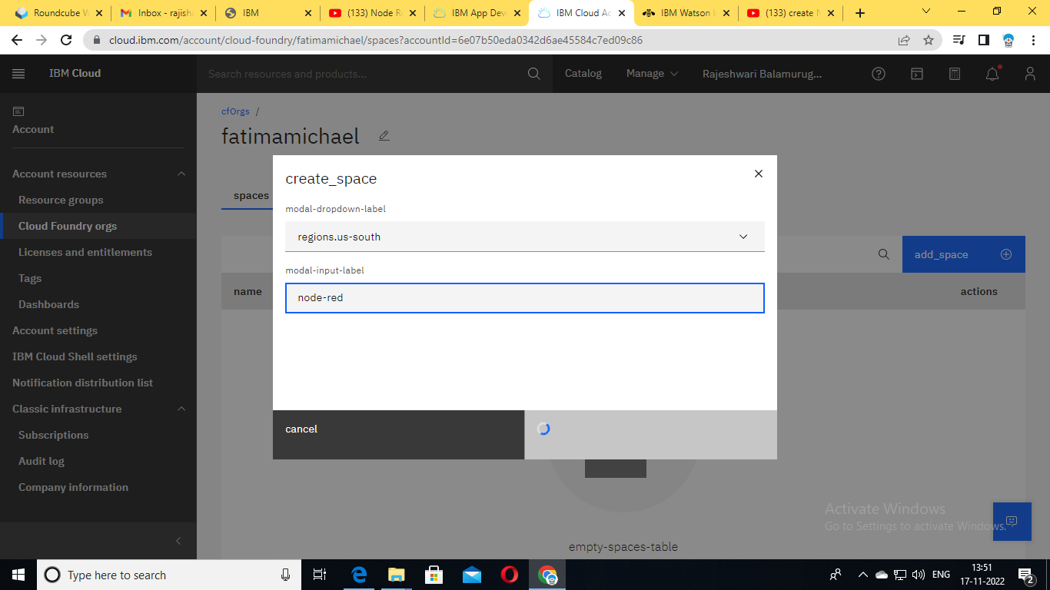

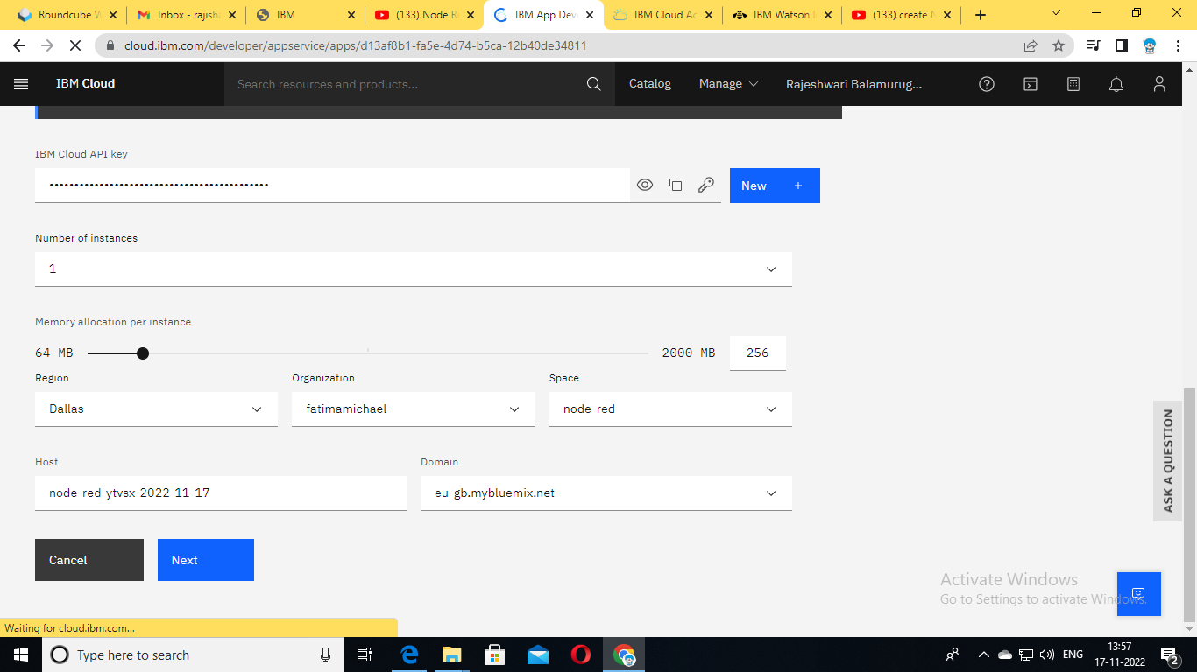

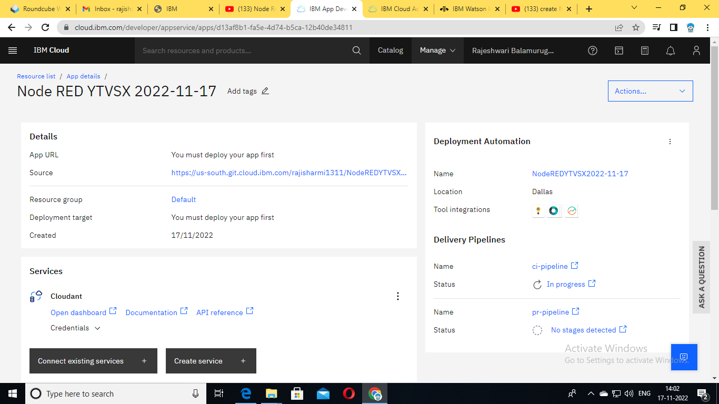

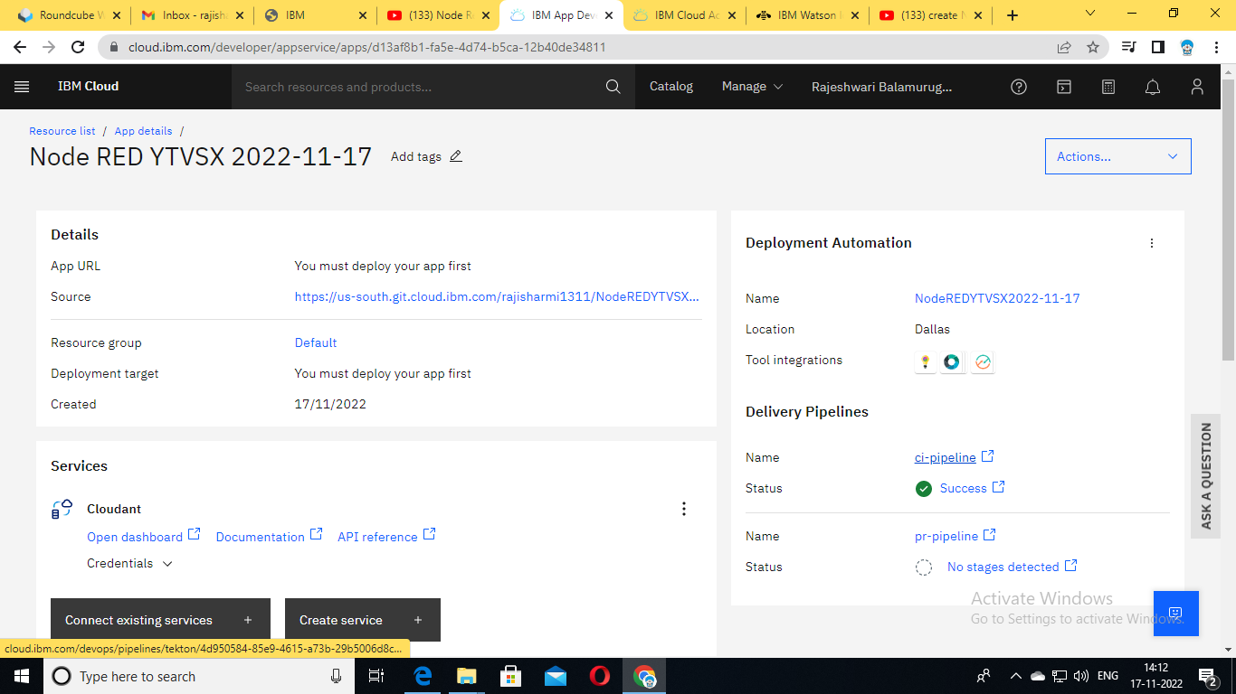

**CREATE DATABASE IN CLOUDANT DB:**

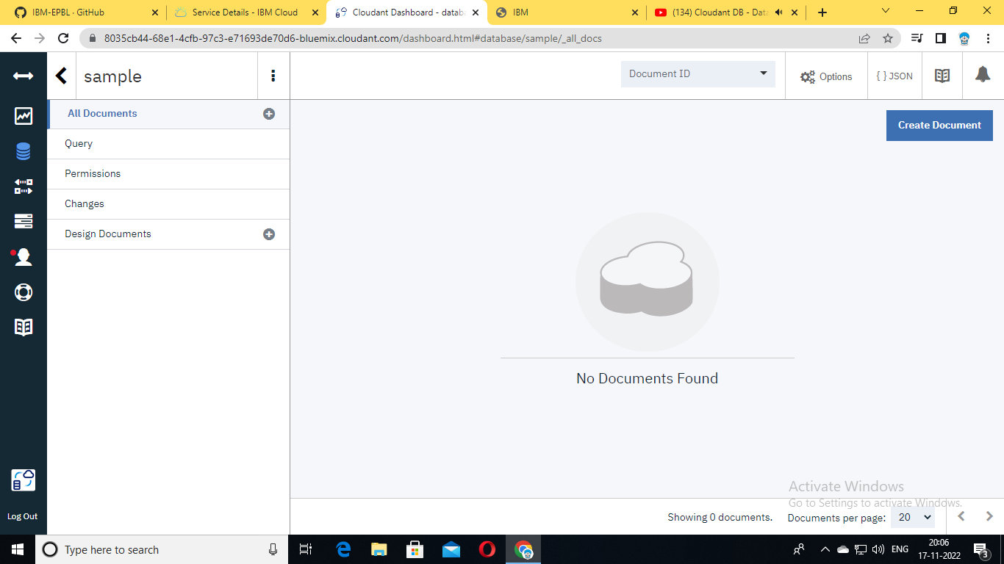 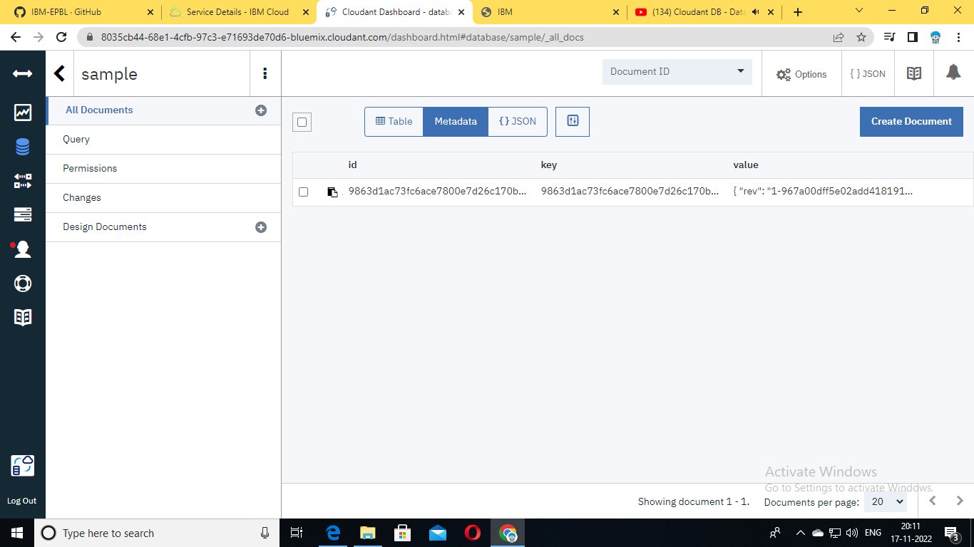 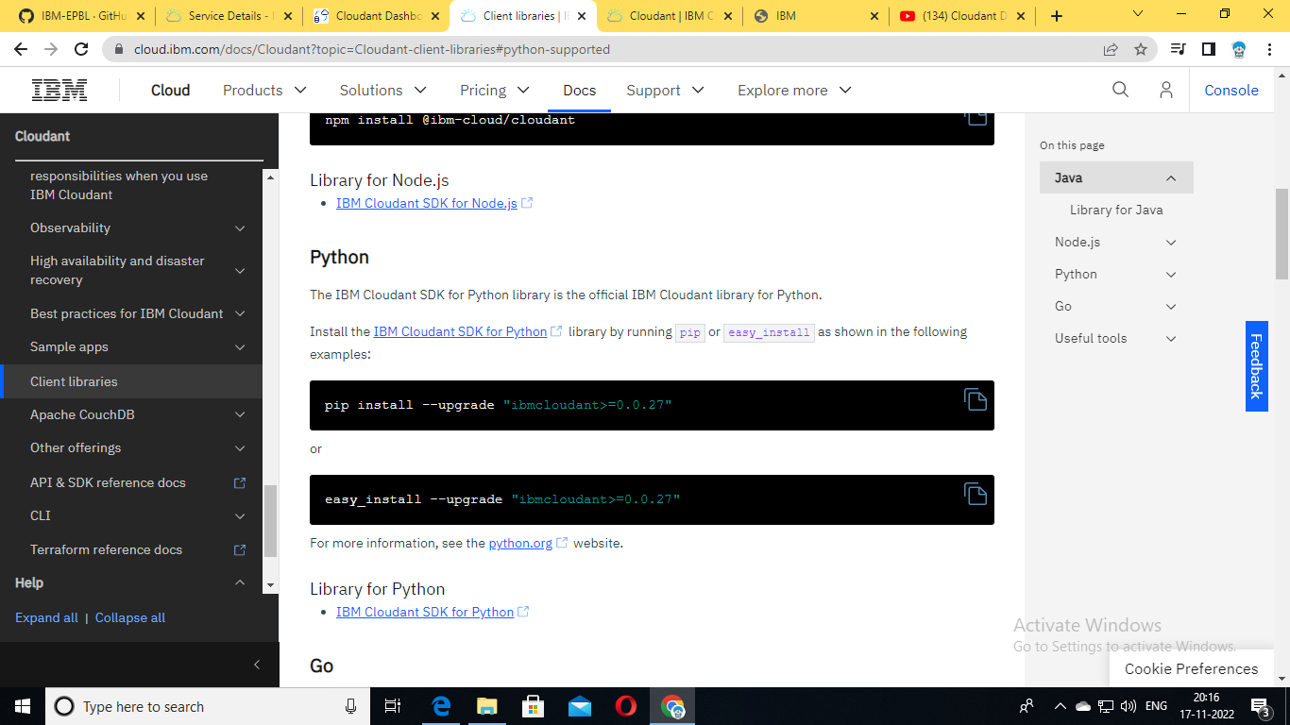 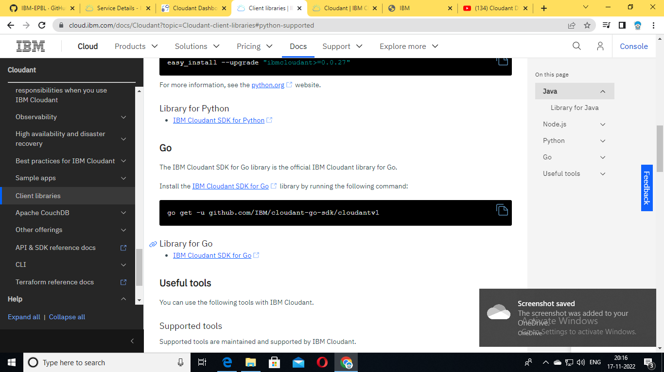

**CREATE OBJECT STORAGE DEVICE:**

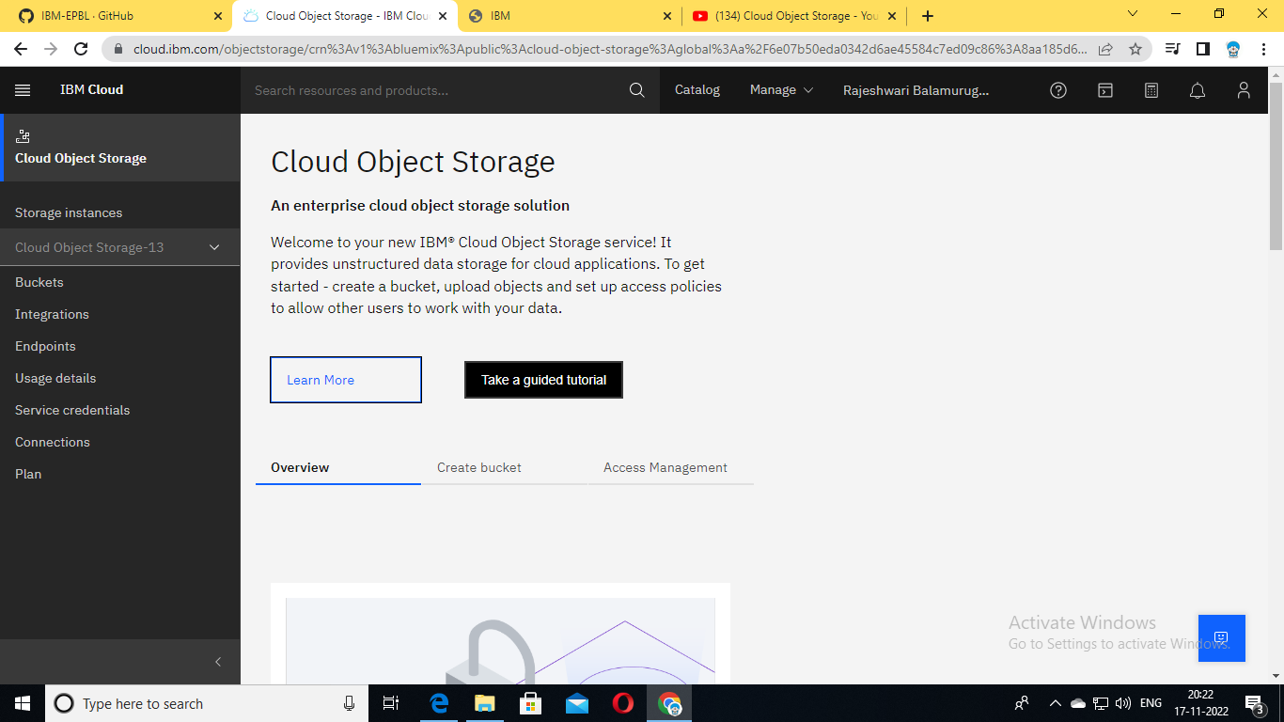 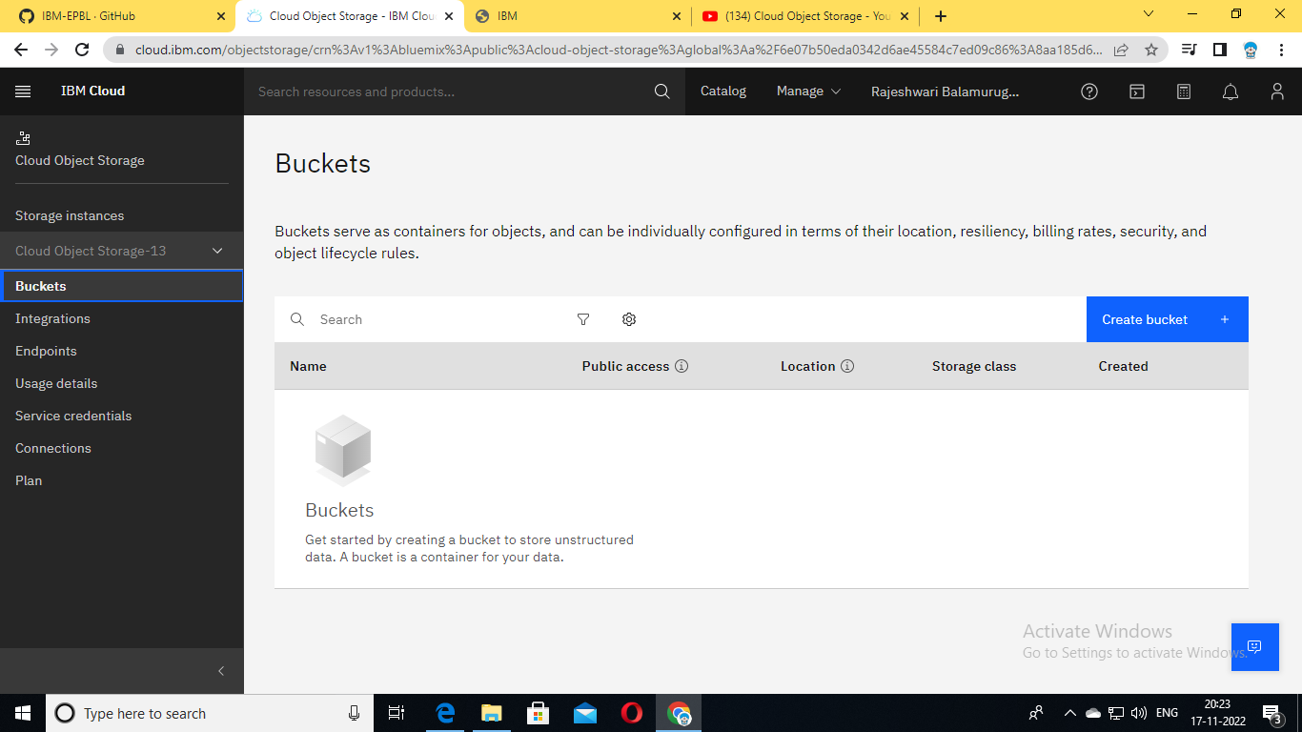 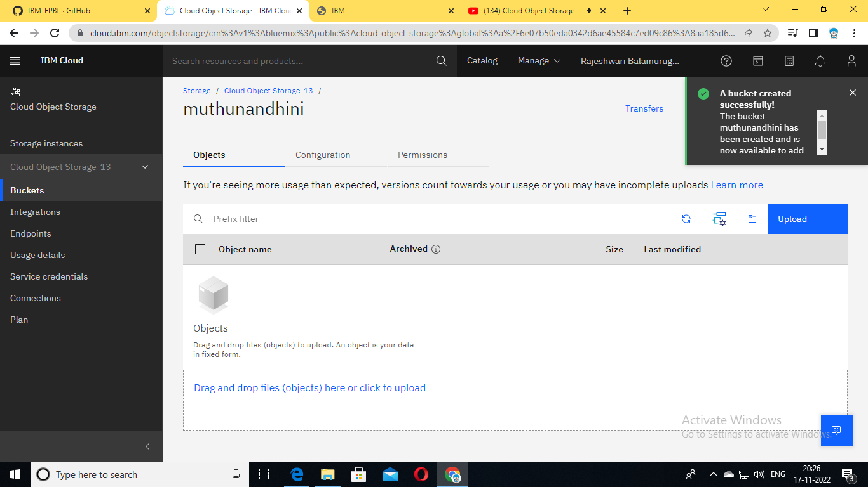 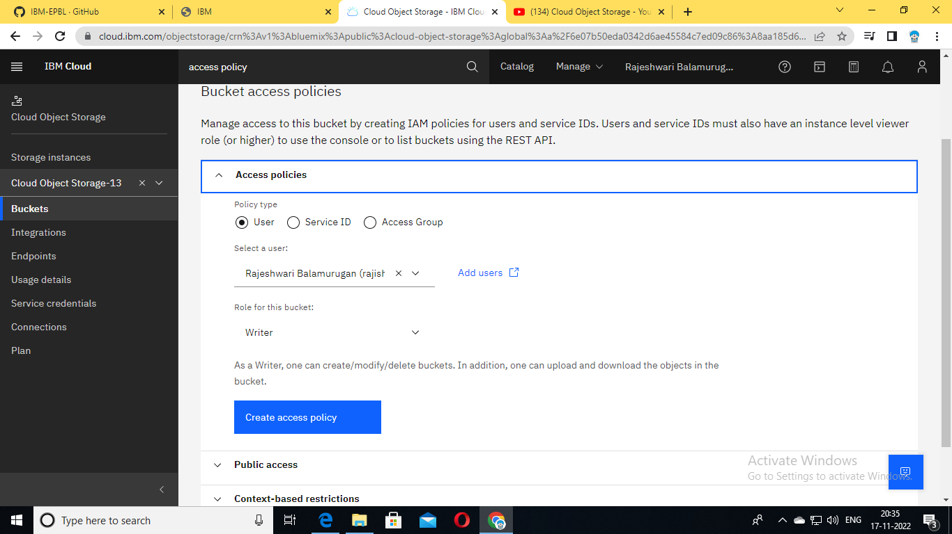 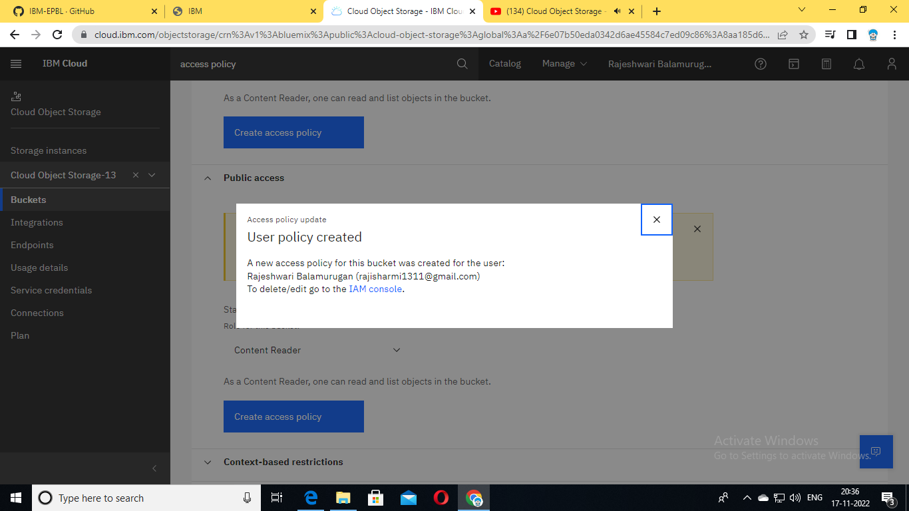 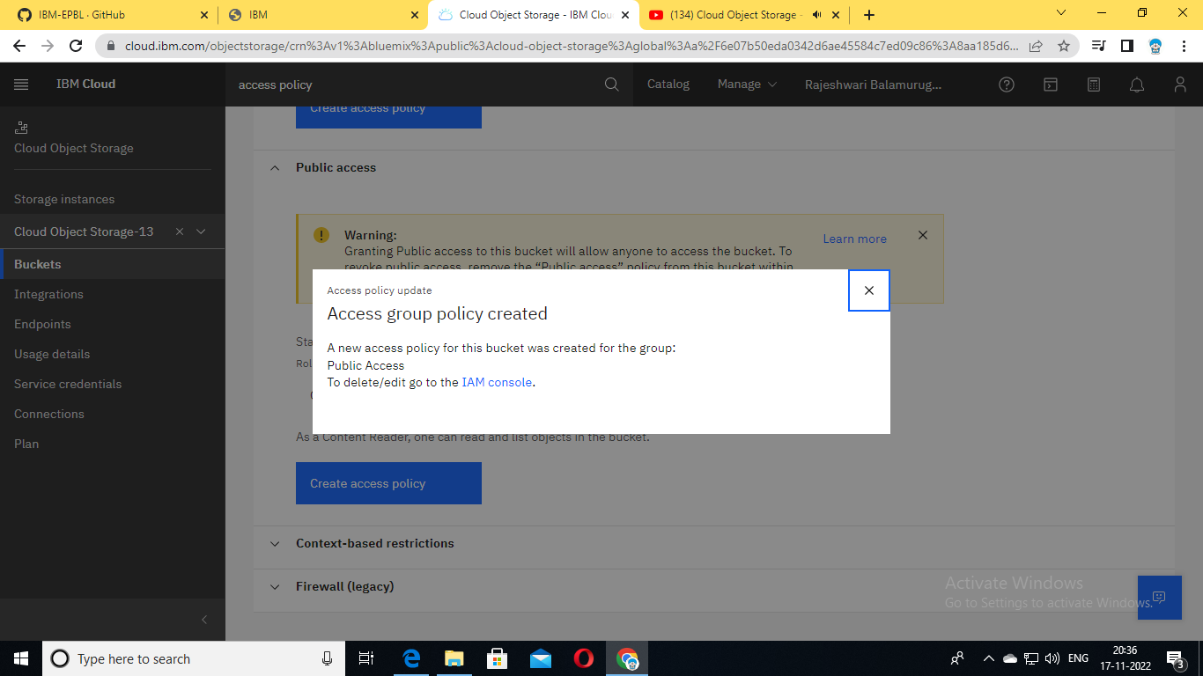 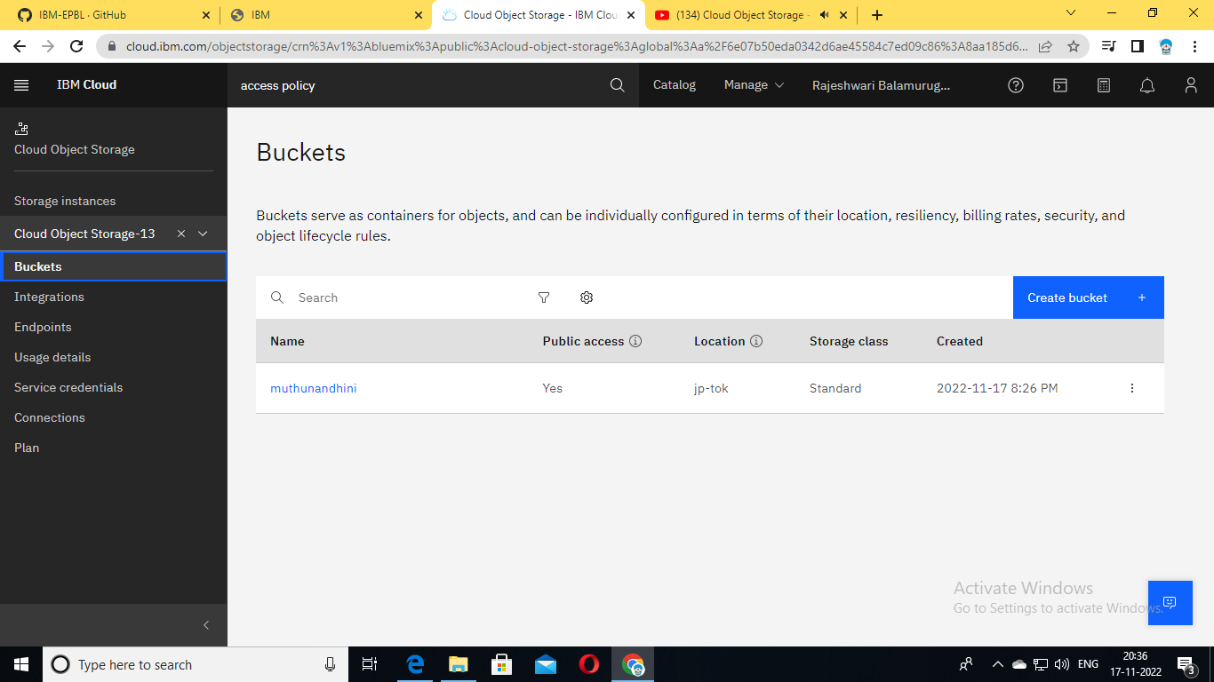

**DEVELOP A WEB APPLICATION USING NODE RED:**

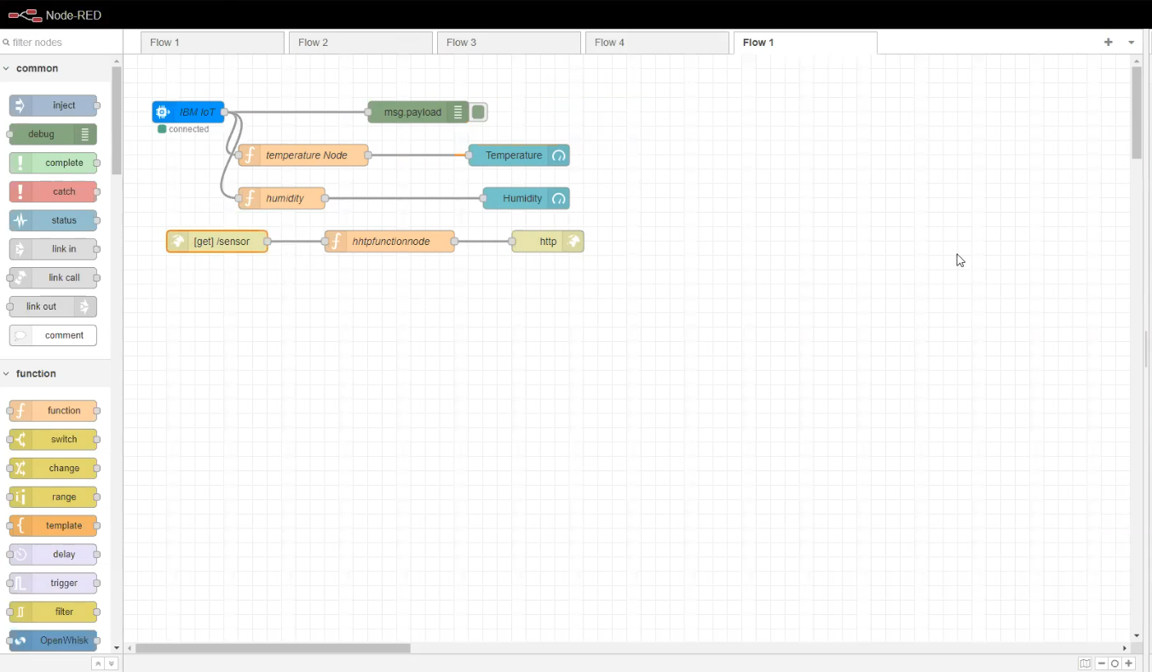

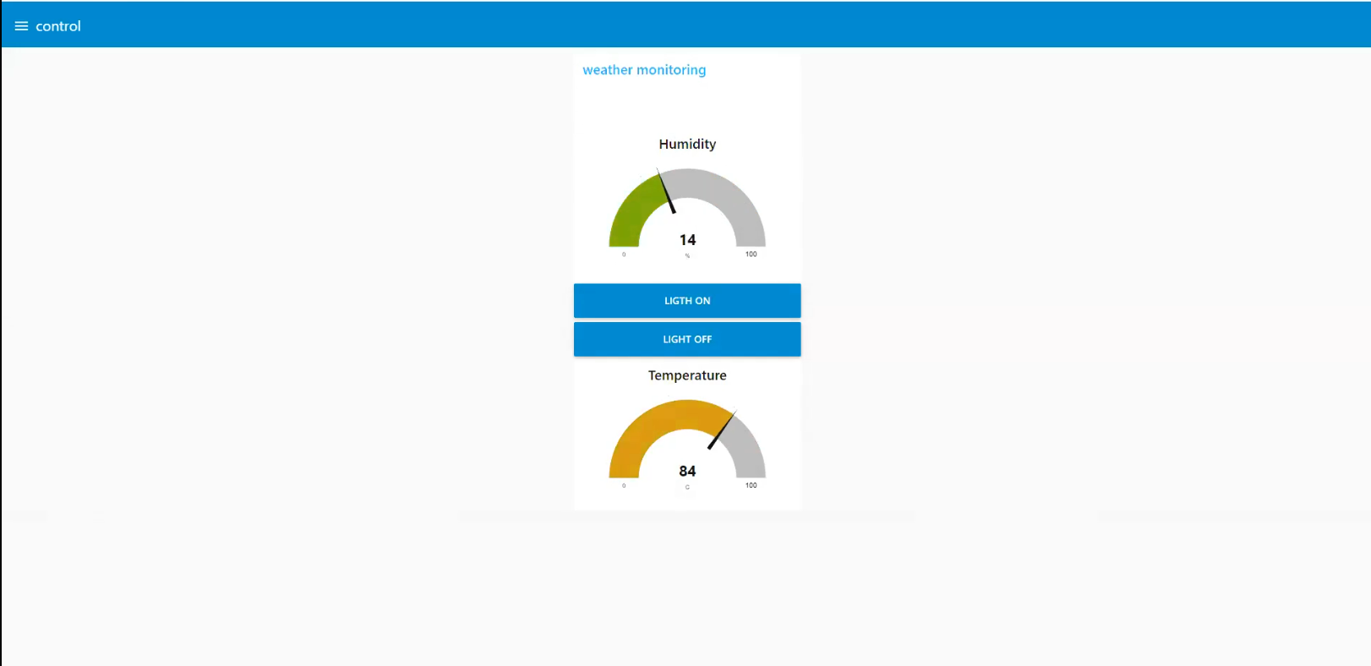

**DEVELOP MIT APP:**

**Step 1: MIT app invertor to design the app**

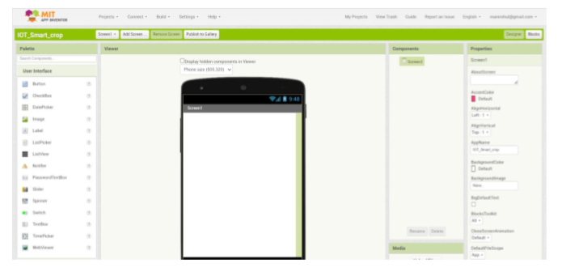

**Step 2: customize the app interface to display the values**

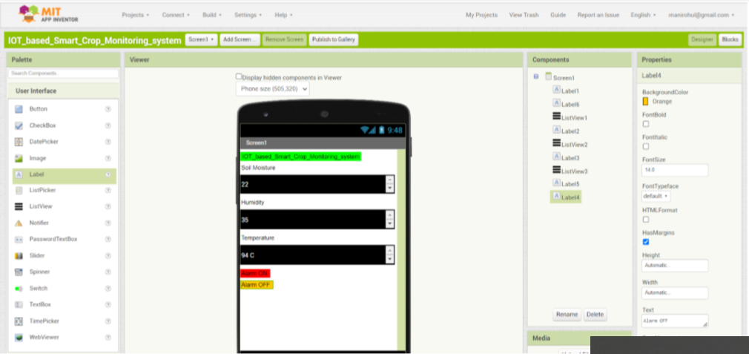

**ADVANTAGES:**

* Reduce human work
* Less cost
* More efficient
* Smart work

**APPLICATIONS:**

* Fields
* Railway station
* Road crossing
* Industrial areas
* Lift

**CONCLUSION:**

The experimental results are obtained for particular animals like Dog, Cow and Cats. It was successfully tested. It is a new approach in social aspects for wild animal death avoidance and accidents prevention. Animal specific frequency spectrum signals are generated. The specific animals are alerted with these signals of danger and successfully ran away. System can be added on vehicles or trains instead of mounting poles on road side.

DEMO LINK: https://youtu.be/O8oAf_UKH_U